**Lab CSS**

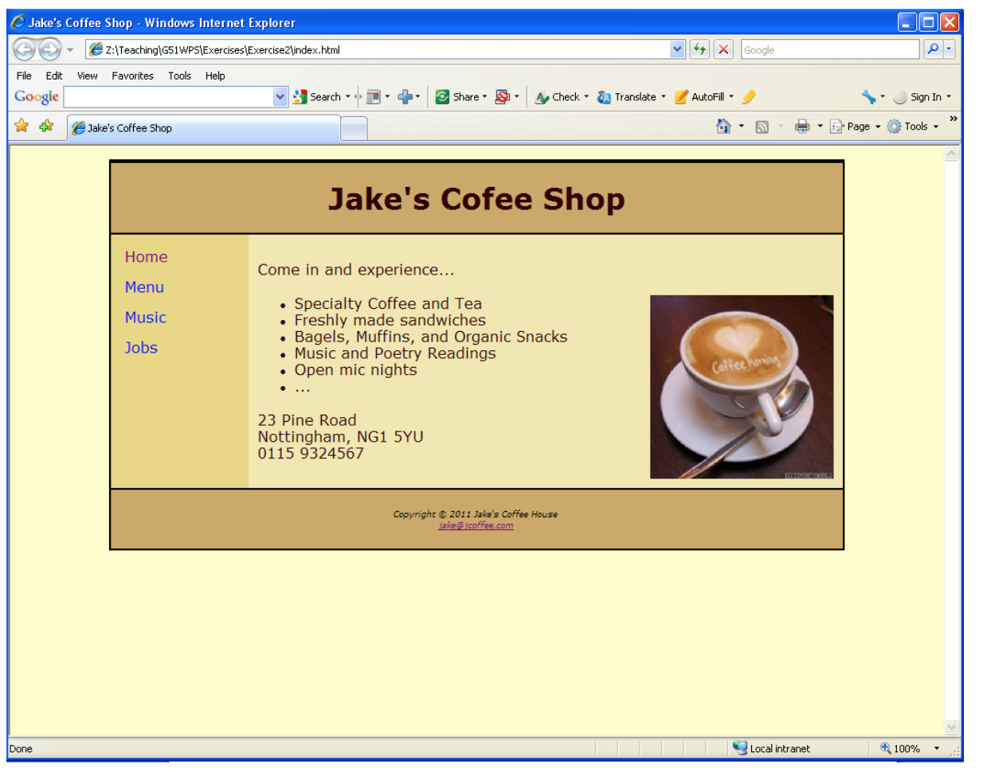

The colors used are as follows:

Text: #330000

Body background: #ffffcc

Header and footer background: #ccaa66

Left (navigation) column background: #E8D882

Right (main content) column background: #f1e8b0

The text is displayed in Verdana font. You should write an external CSS file. You need to modify the original HTML file only to link to this style sheet, mark up sections (using

tags) and set appropriate class and id attributes.